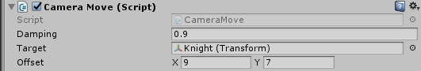
Damping - degree of motion smoothing.
Target - is the target followed by the camera.
Offset – The offset of the camera from the target.
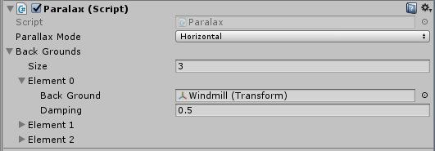
Parallax Mode - parallax mode.
Horizontal - only a horizontal movement.
Vertical - only a vertical movement.
Horizontal and Vertical - horizontal and vertical movement.
Back Grounds - objects subject to parallax
Back Ground – the object that will move. Important: the Z coordinate of object
must not be 0.
Damping – degree of parallax effect.
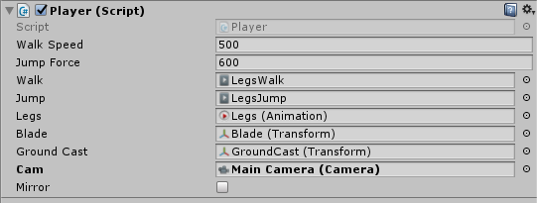
Walk Speed - speed of the player's movement.
Jump Force - player's jump power.
Walk, Jump - animations of walking, jumping.
Blade – sword of the player. Follows the mouse cursor.
Ground Cast - A point that checks whether the player is on the ground.
Cam - camera tracking the player.
Mirror - A reflection of the player on the Y axis.
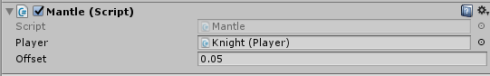
Player – object with "Player" script"
Offset - the degree of elongation of the mantle in motion

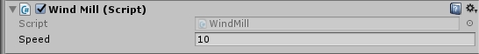
Speed – rotation speed.

